Conversion Guide
Brick Collection: Hematology
There are now two editions of the Hematology Brick collection available. This document provides an overview of the changes and what it means for you and your students.

As part of our commitment to provide up-to-date medical education solutions for medical schools worldwide, the ScholarRx Medical Education team recently made updates to the Hematology Brick collection.

When searching for Bricks on the platform, the collections will default to the latest collection (Edition 2). You can always access the previous edition of a collection via the new toggle option. To toggle to a previous edition, select the desired edition from the new dropdown box located at the top right of the screen. Please see images below for examples.

Brick Exchange:
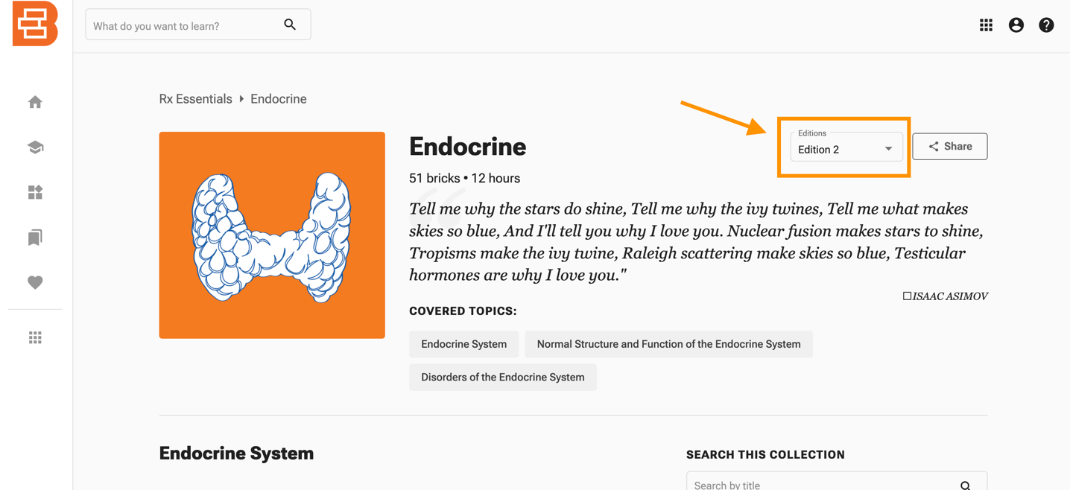

Bricks Create (Faculty Portal):
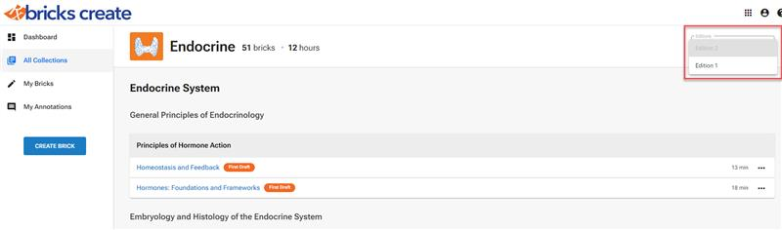

You can also toggle to a previous edition of a Brick within the individual Bricks in both the Brick Exchange and Bricks Create (Faculty Portal). Please see images below for examples.

Brick Exchange:

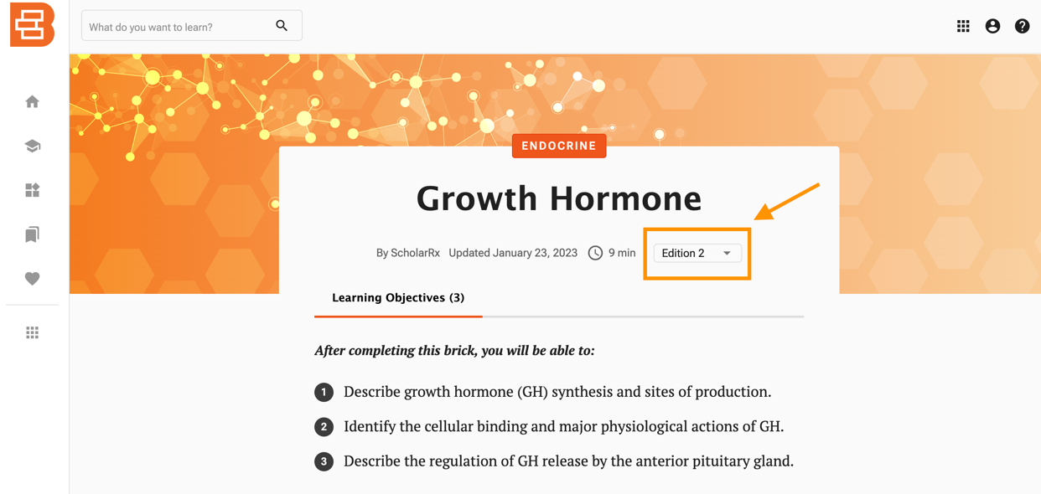

Bricks Create (Faculty Portal):
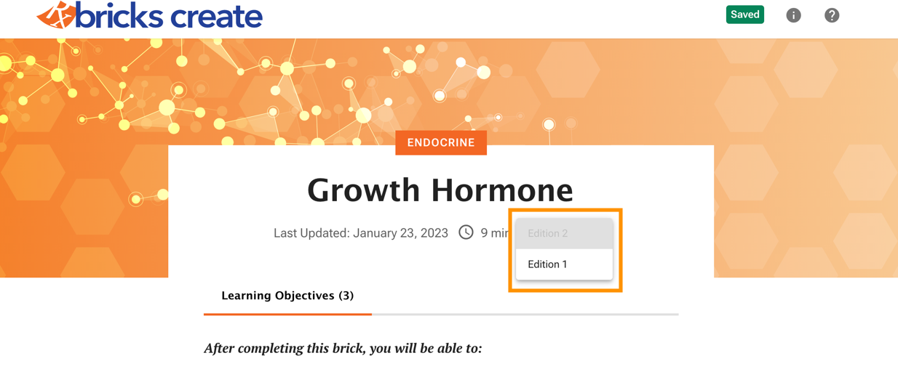

What do these updates mean for Bricks that you have already shared via links in your LMS and elsewhere? While Bricks are never removed from the platform, the links may have changed. Please review the scenarios below as you may need to update any links previously shared in your LMS and elsewhere. Overall, each Brick in the collection has been revised. The default is to direct students to the latest version of the Brick. If you would like students to be redirected to Edition 1 of the Brick, you will need to replace that link with the link from the Edition 1 collection. Please see instructions at the top of this document to access an earlier edition of a Brick collection. If you wish to continue using the Edition 1 version of these Bricks, please note, they will not be updated moving forward.

Changes to the collection include the renaming and revision of some Bricks to better reflect the content. There are also Bricks that have been merged, while others have been removed. New Bricks have also been created and added to the collection. Below is an overview of those changes and what they mean for you and your students.

Merged Bricks
In some cases, two or more Bricks have been combined into a single Brick to best represent the content.

We outlined these instances below:

Individual Bricks | Merged Brick
Anatomy of the Spleen | Structure and Function of the Spleen
Histology and Function of the Spleen
Hematopoietic Malignancies: Foundations and Frameworks | Hematopoietic Neoplasms: Foundations and Frameworks
Lymphoma: Foundations and Frameworks
Structure and Function of Neutrophils | Structure and Function of Neutrophils, Eosinophils, Basophils, and Mast Cells
Structure and Function of Basophils
Structure and Function of Eosinophils
Structure and Function of Lymphocytes | Structure and Function of Monocytes and Lymphocytes
Structure and Function of Monocytes
Factor V Leiden | Genetic Thrombotic Disorders
Antithrombin Deficiency
Protein C and Protein S Deficiencies
Factor II Genetic Mutation
Chronic Lymphoproliferative Disorders: Foundations and Frameworks | Low-Grade B-Cell Non-Hodgkin Lymphomas
Chronic Lymphocytic Leukemia/Small Lymphocytic Lymphoma
Hairy Cell Leukemia
Follicular Lymphoma
Mucosa-Associated Lymphoid Tissue Lymphoma
Diffuse Large B-Cell Lymphoma | High-Grade B-Cell Non-Hodgkin Lymphomas
Burkitt Lymphoma
Anatomy of the Thymus | Structure, Function, and Disorders of the Thymus
Histology and Function of the Thymus
Acute Myeloid Leukemia: Foundations and Frameworks | Acute Myeloid Leukemia
Acute Myeloid Leukemia with Recurrent Genetic Abnormalities
Acute Myeloid Leukemia, Therapy Related
Acute Myeloid Leukemia, Not Otherwise Specified

What does this mean for you?
Any previously shared link is still active. For your convenience, the links to the Edition 1 Bricks have been hyperlinked above. You may wish to continue using the Edition 1 version of these Bricks, but please note, they will not be updated moving forward. If you would like to replace the link in favor of the new, Edition 2 Brick, you will need to update your link. These Edition 2 Brick links have been provided above.

Renamed Bricks
Each of the following bricks have been reviewed, updated, and renamed:

- Plasma Composition à Blood: Foundations and Frameworks
- Erythrocyte Laboratory Tests à Red Blood Cell Laboratory Tests
- Anemia of Chronic Disease à Anemia of Chronic Disease/Inflammation
- Benign Leukocytoses à Benign Leukocytosis
- Hematopoietic Malignancies: Foundations and Frameworks à Hematopoietic Neoplasms: Foundations and Frameworks
- Myelodysplastic Syndromes à Myelodysplastic Neoplasms
- Chronic Myeloproliferative Disorders: Foundations and Frameworks à Myeloproliferative Neoplasms: Foundations and Frameworks
- Chronic Myelofibrosis à Primary Myelofibrosis
- Benign Follicular Hyperplasia and Benign Interfollicular Hyperplasia à Benign Lymph Node Disorders and Lymphadenopathy
- Myeloma and Other Plasma Cell Disorders à Multiple Myeloma and Other Plasma Cell Disorders
- The Coagulation Cascade à Coagulation Cascade
- Idiopathic Thrombocytopenic Purpura à Immune Thrombocytopenia
- Antiphospholipid Antibodies à Antiphospholipid Antibody Syndrome
- Thrombolytics à Thrombolytic Drugs
- Anticoagulants à Anticoagulant Drugs

What does this mean for you?
Any previously shared link will direct students the Edition 1 of the Brick, in other words, the original Brick that you shared. Please review any previously shared links to the Edition 1 Bricks. For your convenience, the links to the Edition 1 Bricks have been hyperlinked above. You may wish to continue using the Edition 1 version of these Bricks, but please note, they will not be updated moving forward. If you would like to replace the link in favor of the new, Edition 2 Brick, you will need to update your link. These Edition 2 Brick links have been provided above.

Deleted Bricks
The following Bricks were DELETED:
- Mantle Cell Lymphoma
- Hematopoiesis in the Fetus
- Heme Metabolism
- Erythrocyte Metabolism
- Antioxidants
- Microangiopathic Hemolytic Anemia
- Anemia of Chronic Renal Disease
- Anemia of Chronic Liver Disease
- Chronic Granulomatous Disease

What does this mean for you?
The links to these Bricks are still active and no action is needed on your part. If you would like to view these Bricks in the previous Table of Contents of the collection, you can toggle the Edition dropdown menu as outlined in the beginning of this article. The deleted Bricks are hyperlinked above.

New Bricks
The following Bricks are NEW Bricks:
- Thrombocytopenia
- Disorders of the Spleen

What does this mean for you? These are newly created Bricks that we encourage you to check out!

Annotations
- If no changes were made to the Brick, your annotations will carry forward to the Brick in the new edition of the Collection.
- If the Brick was deleted from the new edition of the Collection, the annotations will remain in the Brick in the previous edition of the Collection.
- If the content in the section where the annotation is located was updated, the annotation will detach and remain available in the side bar. You will need to reattach your annotation.
- If the Brick was split, you will need to review the Brick(s). In some cases, the annotation will either carry forward, detach and remain available in the side bar, or be deleted. You will need to review these Bricks and your annotations.
  - If you would like to use the Edition 1 of the Brick with the original annotations, you can update the link to the Edition 1 version, but please note that Edition 1 Bricks will no longer be updated.

