Conversion Guide
Brick Collection: Cardiovascular
There are now two editions of the Cardiovascular Brick collection available. This document provides an overview of the changes and what it means for you and your students.

As part of our commitment to provide up-to-date medical education solutions for medical schools worldwide, the ScholarRx Medical Education team recently made updates to the Cardiovascular Brick collection.

When searching for Bricks on the platform, the collections will default to the latest collection (Edition 2). You can always access the previous edition of a collection via the new toggle option. To toggle to a previous edition, select the desired edition from the new dropdown box located at the top right of the screen. Please see images below for examples.

Brick Exchange:
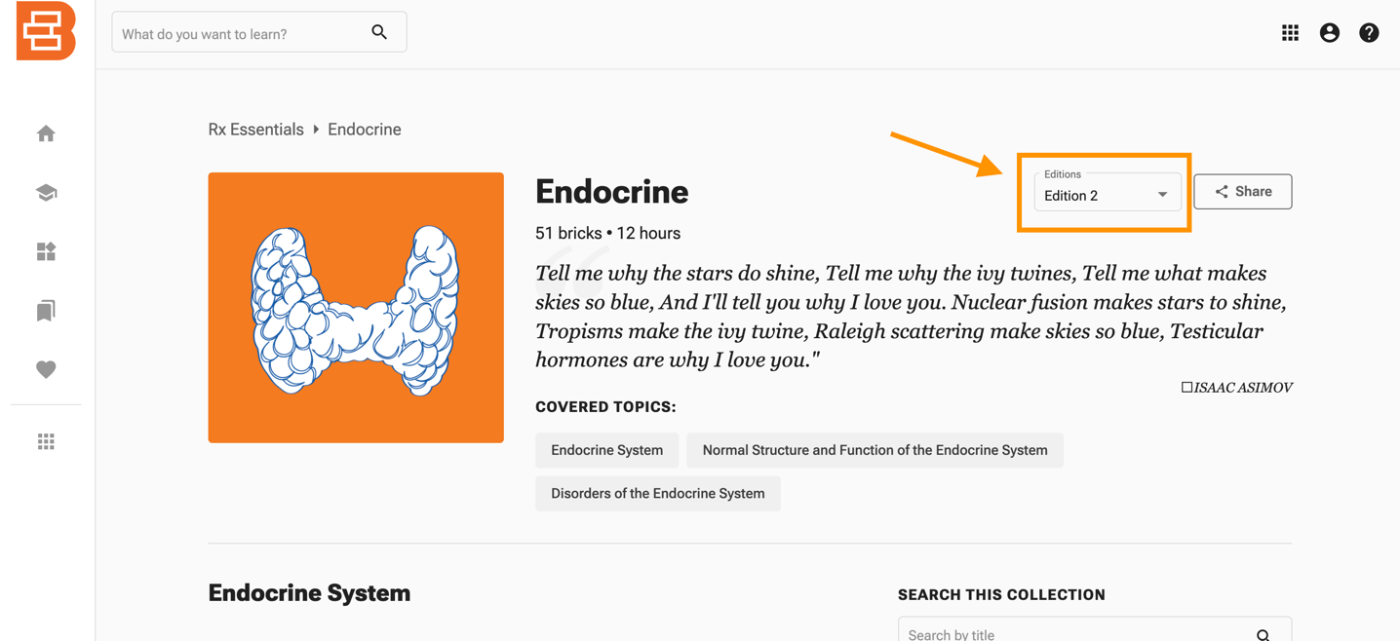

Bricks Create (Faculty Portal):
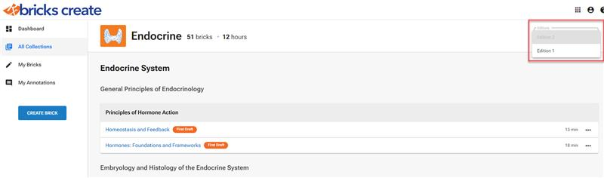

You can also toggle to a previous edition of a Brick within the individual Bricks in both the Brick Exchange and Bricks Create (Faculty Portal). Please see images below for examples.

Brick Exchange:

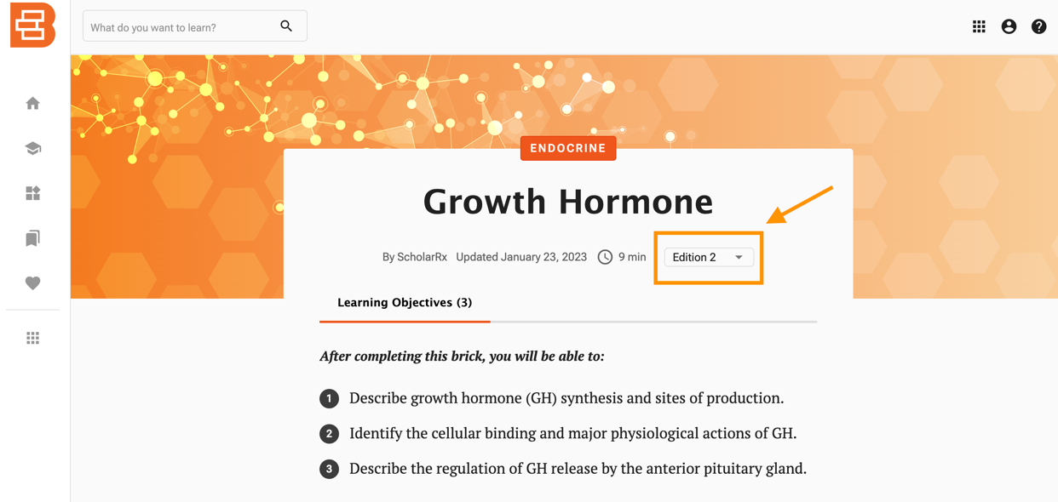

Bricks Create (Faculty Portal):
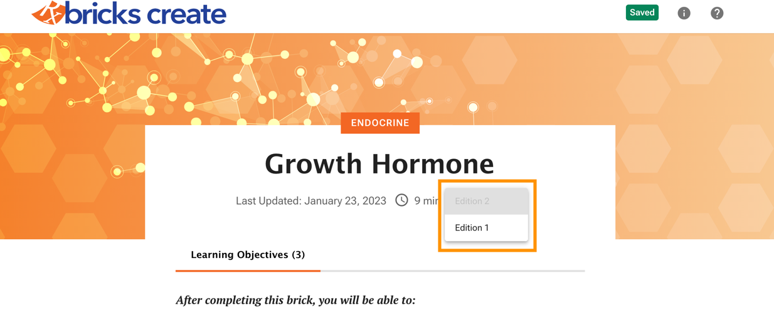

What do these updates mean for Bricks that you have already shared via links in your LMS and elsewhere? While Bricks are never removed from the platform, the links may have changed. Please review the scenarios below as you may need to update any links previously shared in your LMS and elsewhere.

Split Bricks
A split Brick is a Brick that has been divided into multiple Bricks in order to best present the content. If you previously shared a link to a Brick that has been split, we recommend that you review that Brick. Any previously shared links will direct students to the Edition 1 version of the Brick. You may choose to replace the previously shared link with links to the new Bricks that have been split from the original.

Please note, any Edition 1 Bricks will no longer be updated. We highly recommend that you review these Bricks and choose the link(s) that fit your curriculum.

We outlined these instances below:

- Aortic and Berry Aneurysms
  - à Aortic Aneurysm
  - à Aortic Dissection
- Normal ECG
  - Electrocardiogram Part 1: Fundamentals and Lead Placement
  - Electrocardiogram Part 2: Waves, Intervals, and Segments
- Pericarditis
  - Constrictive Pericarditis
  - Acute Pericarditis
- Class I, II, III, and IV Drugs
  - Antiarrhythmic Drugs (Classes I and III)
  - Antiarrhythmic Drugs (Classes II, IV, and V)

What does this mean for you?
Any previously shared link will direct students the Edition 1 of the Brick, in other words, the original Brick that you shared. Please review any previously shared links to the Edition 1 Bricks. For your convenience, the links to the Edition 1 Bricks have been hyperlinked above. You may wish to continue using the Edition 1 version of these Bricks, but please note, they will not be updated moving forward. If you would like to replace the link in favor either or both of the new, Edition 2 Bricks, you will need to update your link(s). These Edition 2 Brick links have been provided above.

Additional changes to the collection include the renaming and revision of some Bricks to better reflect the content. There are also Bricks that have been moved from other collections into this collection, while others have been removed. New Bricks have also been created and added to the collection. Below is an overview of those changes and what they mean for you and your students.

Merged Bricks
In some cases, two or more Bricks have been combined into a single Brick to best represent the content.

We outlined these instances below:

Individual Bricks | Merged Brick
Electrolytes and Ion Channels in the Heart | Cardiac Muscle Contraction
Cardiac Muscle Excitation and Contraction

What does this mean for you?
Any previously shared link is still active. For your convenience, the links to the Edition 1 Bricks have been hyperlinked above. You may wish to continue using the Edition 1 version of these Bricks, but please note, they will not be updated moving forward. If you would like to replace the link in favor of the new, Edition 2 Brick, you will need to update your link. These Edition 2 Brick links have been provided above.

Renamed Bricks
Each of the following bricks have been reviewed, updated, and renamed:

- Action Potentials of Heart Cells à Cardiac Action Potentials
- Acyanotic Congenital Heart Defects: Foundations and Frameworks à Congenital Heart Defects: Foundations and Frameworks
- Angina à Angina Pectoris
- Blood Pressure: Foundations and Frameworks à Blood Pressure Control: Foundations and Frameworks
- Cardiac and Vascular Function Curves: Foundations and Frameworks à Cardiac and Vascular Function Curves
- Cardiac Muscle Contractility à Contractility, Preload, and Afterload
- Cardiac Output à Measuring Cardiac Function
- Clinical Features of Heart Failure à Diagnosis of Heart Failure
- Coarctation of the Aorta à Acyanotic Obstructive Congenital Heart Defects
- Control of Blood Flow in the Microcirculation à Local Control of the Microcirculation
- Coronary Vascular Anatomy à Vasculature and Lymphatics of the Heart
- Cyanotic Congenital Heart Defects: Foundations and Frameworks à Cyanotic Mixing Congenital Heart Defects
- Drugs to Treat Acute Coronary Syndrome à Treatment of Acute Coronary Syndrome
- Drugs to Treat Heart Failure à Management of Chronic Heart Failure
- Emergent Hypertension à Hypertensive Emergency
- Fat, Air, Amniotic Fluid, and Other Emboli à Nonthrombotic Emboli
- Heart Block à Heart Block and Nodal Disease
- Heart Murmur Auscultation à Valvular Disease: Putting It All Together
- Hemodynamics à Hemodynamics: Blood Flow
- Histology of Blood Vessels à Histology of Blood Vessels and Lymphatics
- Hypertrophic Cardiomyopathy à Left Ventricular Hypertrophy and Hypertrophic Cardiomyopathy
- Junctional and Ventricular Arrhythmias à Ventricular Arrhythmias and Junctional Escape Rhythms
- Mechanisms of Heart Failure à Physiology of Heart Failure
- Noninfective Endocarditis à Nonbacterial Thrombotic Endocarditis
- Normal Heart Sounds à Heart Sounds
- Pressure-Volume Loops: Foundations and Frameworks à Pressure-Volume Loops
- Rheumatic Heart Disease à Acute Rheumatic Fever and Rheumatic Heart Disease
- Tetralogy of Fallot à Cyanotic Obstructive Congenital Heart Defects
- The Normal Cardiac Cycle à Cardiac Cycle
- Vasopressors, Inotropes, and Vasodilators à Management of Shock

What does this mean for you?
Any previously shared link will direct students the Edition 1 of the Brick, in other words, the original Brick that you shared. Please review any previously shared links to the Edition 1 Bricks. For your convenience, the links to the Edition 1 Bricks have been hyperlinked above. You may wish to continue using the Edition 1 version of these Bricks, but please note, they will not be updated moving forward. If you would like to replace the link in favor of the new, Edition 2 Brick, you will need to update your link. These Edition 2 Brick links have been provided above.

Bricks from Other Collections
The following Bricks have been ADDED from other collections:
- Deep Vein Thrombosis
  - previously in the Respiratory collection
- Primary Lipid Disorders
  - previously in the Cellular and Molecular Biology collection
- Renin-Angiotensin-Aldosterone System Inhibitors
  - previously named ACE Inhibitors, ARBs, and Renin Inhibitors and included in the Renal collection

What does this mean for you?
The links to these Bricks are still active. If you previously shared a link to a Brick while it resided in its original collection, that link will redirect the student to the Brick as it appears in the Edition 2 collection. The student will continue to view the Brick content in the same way. The original link and updated link (if you would like to update it) are hyperlinked above.

Deleted Bricks
The following Bricks were DELETED:
- Special Circulations: Heart, Brain, and Skin
- Renin-Angiotensin-Aldosterone Regulation of Blood Pressure
- Emboli: Foundations and Frameworks
- Myocarditis

What does this mean for you?
The links to these Bricks are still active and no action is needed on your part. If you would like to view these Bricks in the previous Table of Contents of the collection, you can toggle the Edition dropdown menu as outlined in the beginning of this article. The deleted Bricks are hyperlinked above.

New Bricks
The following Bricks are NEW Bricks:
- General Organization of the Cardiovascular System
- Hemodynamics: Blood Pressure
- Carotid Stenosis
- Superficial Venous Disease
- Vasculitis: Putting It All Together
- Tricuspid Regurgitation and Tricuspid Stenosis
- Arrhythmias: Foundations and Frameworks
- Hypertension: Foundations and Frameworks
- Obesity and Metabolic Syndrome
- Peripheral Arterial Disease
- Arrhythmias: Putting It All Together
- Sudden Cardiac Arrest and Cardiac Life Support

What does this mean for you? These are newly created Bricks that we encourage you to check out!

Annotations
- If no changes were made to the Brick, your annotations will carry forward to the Brick in the new edition of the Collection.
- If the Brick was deleted from the new edition of the Collection, the annotations will remain in the Brick in the previous edition of the Collection.
- If the content in the section where the annotation is located was updated, the annotation will detach and remain available in the side bar. You will need to reattach your annotation.
- If the Brick was split, you will need to review the Brick(s). In some cases, the annotation will either carry forward, detach and remain available in the side bar, or be deleted. You will need to review these Bricks and your annotations.
  - If you would like to use the Edition 1 of the Brick with the original annotations, you can update the link to the Edition 1 version, but please note that Edition 1 Bricks will no longer be updated.

